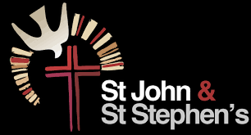
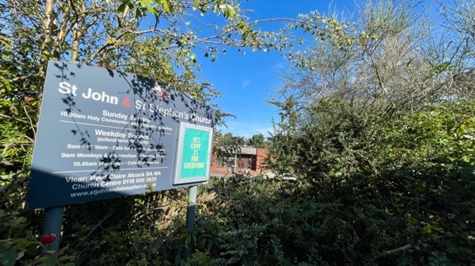
Full Time Youth Minister for St John & St Stephen’s, Reading.

Up to £32,000 per annum depending on experience and qualifications

- Would you like to work in a positive and friendly church family in vibrant East Reading as we seek to grow our youth ministry and reach out to our diverse community?
- Are you gifted and enthusiastic about building youth work to make life-long disciples of Jesus Christ?
- Can you help us to become a truly intergenerational church and work with our local partners to enrich the community?
If so, we’d love to hear from you!
For an informal chat, phone Rev. Claire on 07519861040 or Richard on 07815633098
Full job description, person specification, parish information and application form https://www.stjohnandststephen.org.uk/st-john-and-st-stephens-reading-youth-minister-post
Or email our PCC Secretary at secretary.stjands@gmail.com
Closing Date: 12 noon 08.09.26
Interviews: 16.09.26
(We are happy to hold out longer, however, for the right candidate)


St John and St Stephen’s Church 121-147 Orts Road, RG13JN www.stjohnandststephen.org.uk

