

**Is God calling YOU to…**

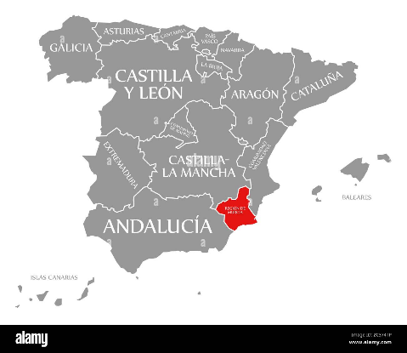**Role of Pastor becoming available…**

**Salt Church Mar Menor** is a small but growing English

Speaking Evangelical Fellowship situated in the Murcia

**MURCIA**

region of south-east Spain comprising folk from a wide

range of denominational backgrounds (and none!)

The Church Family comprises a core of 30 full time residents and is augmented with a number of second home owners who visit regularly.

In addition, we are increasingly being found by holiday makers and those passing through on their travels.

We meet in a building at the heart of a popular shopping centre with plenty of foot traffic passing our premises.

Also, we have built up a successful presence on social media and in the local press.

However, there is a great need for sharing the Gospel out there amongst the English-speaking expats ‘yet to believe’, not only from the UK but across Europe too. Perhaps because it does not look like a typical mission field it is a neglected mission field!

**THESE fields are ripe for harvest, might you be the one that leads our workers in the** **next season of evangelism and discipleship**?

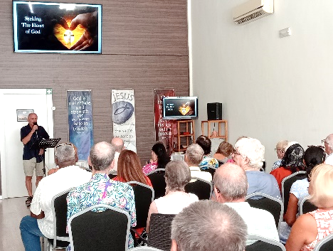

The Church was founded in January 2020 as a satellite congregation from Salt Church (Spain), originally Torrevieja Christian Fellowship, which has been established for nearly 40 years.

We are now a legally registered Association in our own right but continue to be an Associate Fellowship in the Salt Church family.

As such, we are financially independent and oversee our own finance, administration and governance.

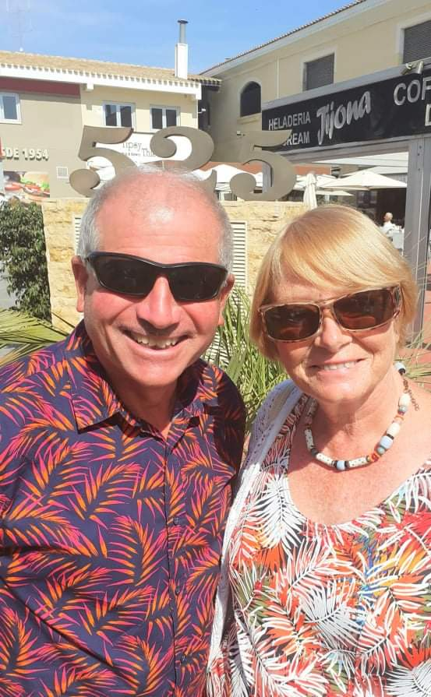Andy & Lynne Neale are the founding pastors and are looking to gradually begin handing over the baton before taking retirement during or before the Autumn of 2026.

The role of pastor is not salaried, but ministry expenses

are paid and the housing costs are covered (rent, utilities, taxes and community fees) in addition to a small allowance.

Ideally, we are looking for a couple who can share this full-time role.

**Might you be…** thinking of early retirement but still have the enthusiasm to preach and pastor, taking this church into the next phase of mission and ministry?

**Might you be…**, a financially supported mission partner with an established agency or, like Andy & Lynne, by personal and independent means?

**Might you be…** self-employed or a ‘Digital Nomad’ able to relocate to Spain and successfully dovetail your time?

**Might you be…** someone who senses that God is simply calling you to investigate further?



**Why not check us out?**

[**www.marmenorchurch.com**](http://www.marmenorchurch.com)

*Salt Church Mar Menor is a member of the Ground Level Network.*

or find us on Facebook

…and catch us on You Tube



If you would like to find out more then please do not hesitate to contact us to chat further.

**andy.neale@marmenorchurch.com**

